Steps to update plugin in Jenkins.

1. Login to Jenkins .

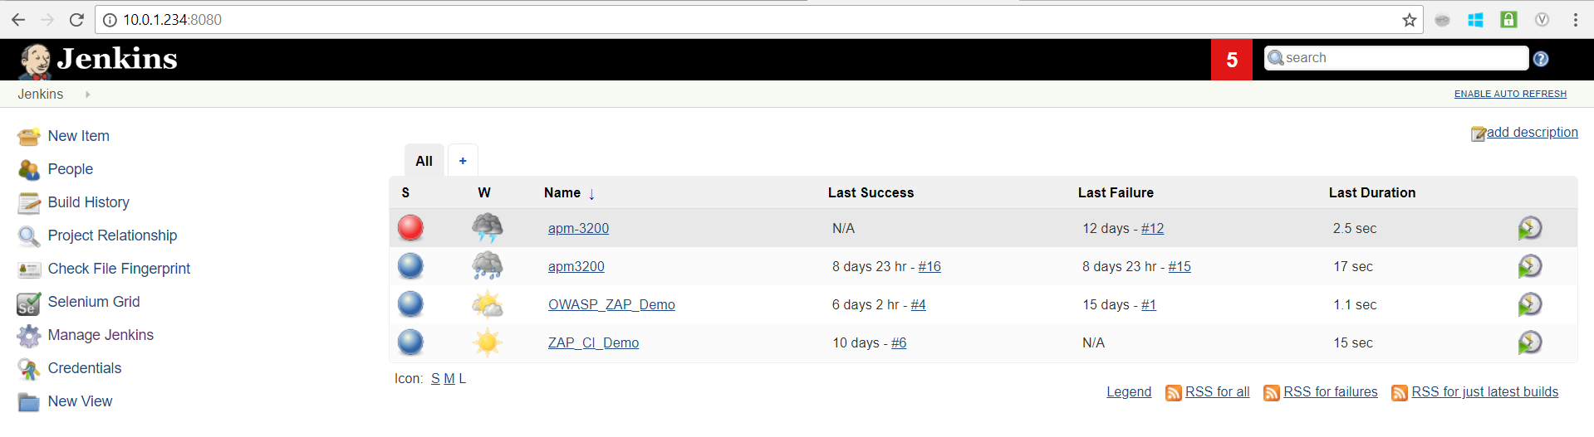

1. Click on Manage Jenkins

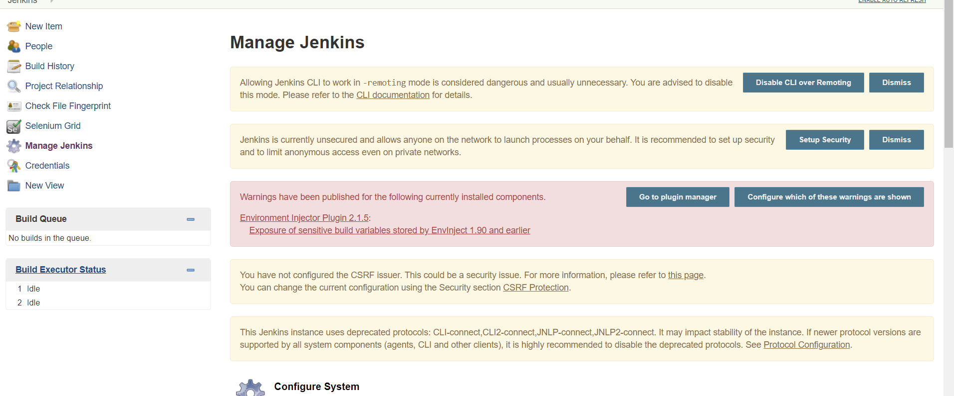

1. Click on Manage Plugins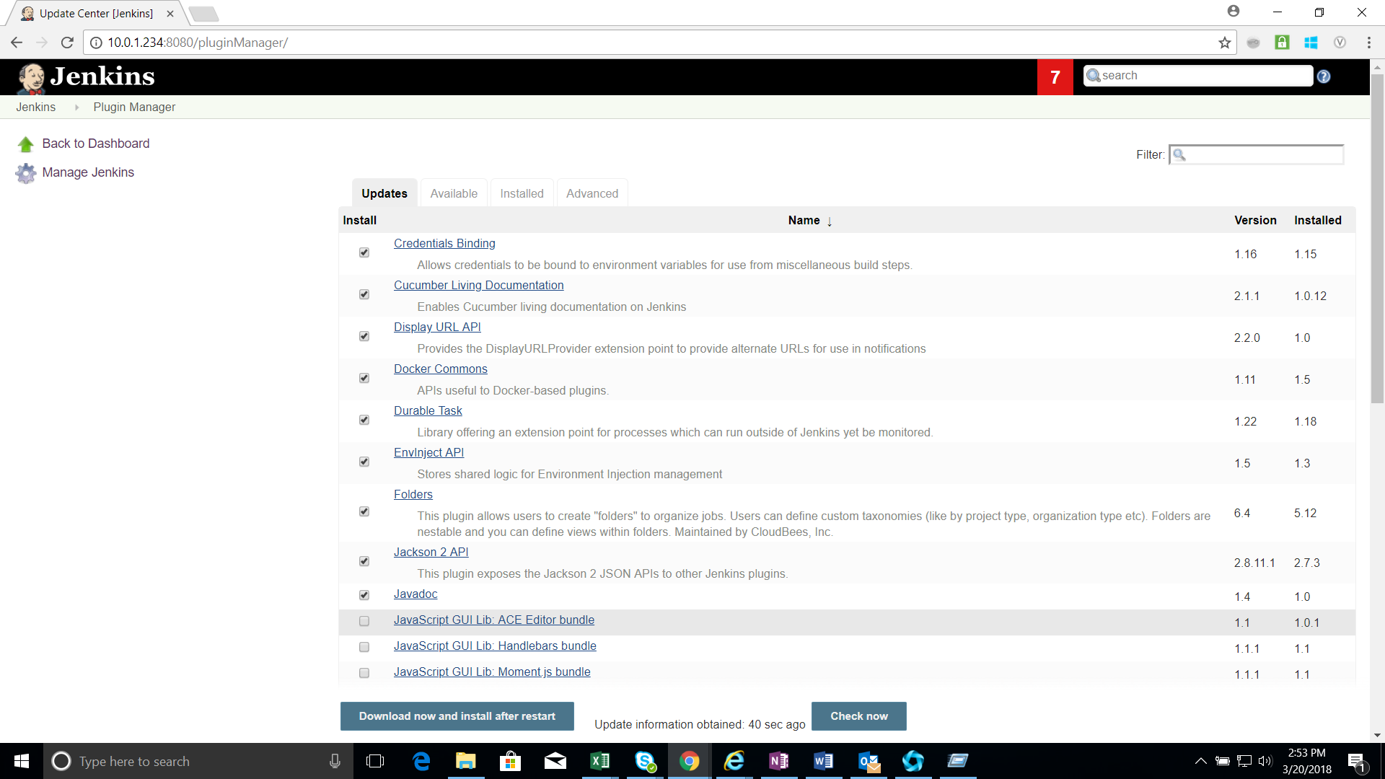
2. Select the Plugins which must be updated and click on Download and install after restart option.

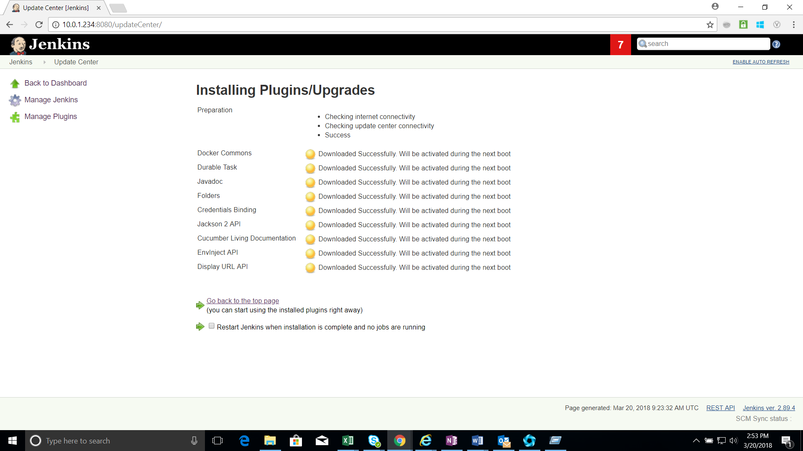

1. Select the check box Restart Jenkins when installation is complete and no jobs are running . The Plugin gets updated after restart.

